
PROGRAMME: APPLIED COMPUTER SCIENCE
SCHOOL:SCHOOL OF APPLIED COMPUTER SCIENCE ENGINEERING AND HEALTH(SSEH)
ACS 400 PROJECT PROPOSAL

STUDENT ID: 22-2204

DECLARATION
I, 22-2204, hereby declare that this project proposal titled "Design and Implementation of an Automated Router Configuration Backup System for Educational and Small-Scale ISP Environments" is my original work and has been carried out under the guidance of my supervisor and in accordance with the regulations and standards set by Daystar University.
This proposal represents the culmination of independent research, critical analysis, and technical planning conducted during my studies in Applied Computer Science. All sources of information, including books, journal articles, online resources, software documentation, and prior research works, have been duly acknowledged and appropriately cited within the text and listed in the references section using the prescribed citation style (APA).
I affirm that:
- The ideas, designs, methodologies, and written content presented in this document are the result of my own intellectual effort.
- Where external materials have been referenced, quoted, or adapted, proper acknowledgment has been given to avoid plagiarism.
- No part of this proposal has been submitted for any other degree, diploma, or certification in this or any other institution.
- The system design, diagrams, code logic, and implementation plan described herein were developed by me as part of a structured learning process aimed at acquiring practical skills in network automation, scripting, and systems analysis.
- Any use of open-source tools, libraries (such as Python, netmiko, GNS3, or Cisco Packet Tracer), or existing frameworks has been done strictly for educational purposes and in compliance with their respective licensing terms.
Furthermore, I acknowledge that while this project draws inspiration from real-world systems such as Ubiquiti UniFi Controller, RANCID, and Ansible, its purpose is not commercial replication but rather pedagogical exploration, to understand, simulate, and learn from established practices in network configuration management without infringing on intellectual property rights.
I also confirm that all simulations, testing procedures, and hardware interactions described in this proposal were conducted in controlled, non-disruptive environments, either through virtualization platforms (e.g., WSL, GNS3) or on devices under my ownership or authorized access, ensuring no unauthorized access to third-party networks or breach of cybersecurity policies.
This proposal reflects honest effort, rigorous investigation, and adherence to academic ethics. It is submitted in partial fulfillment of the requirements for the Final year Project, and I accept full responsibility for its content.

TABLE OF CONTENTS

PROJECT PROPOSAL 4
Remote Auto-Reconfiguration and Network Device Management System 4
CHAPTER ONE 5
1.0 Introduction 5
1.1 Background of the Study 5
1.2 Statement of the Problem 7
1.3 Main Objective 9
1.4 Specific Objectives 9
1.5 Significance of the Study 9
1.6 Scope of the Study 10
1.7 Justification of the Proposed System 10
The justification lies in bridging the gap between costly enterprise solutions and inflexible vendor-tied platforms. While large providers can afford proprietary systems, smaller ISPs require affordable, interoperable solutions. 10
The proposed system is justified on the following grounds: 10
✓ Economic Value: Reduces operational costs tied to on-site troubleshooting. 10
✓ Efficiency: Enables faster response times and service restoration. 10
✓ Scalability: Supports growth in user base without exponential increase in support costs. 10
✓ Practicality: Leverages well-established protocols and APIs that already exist in most routers and switches. 10
✓ Knowledge Gap Bridging: Builds on previous academic work while tailoring to practical ISP challenges in emerging markets. 10
CHAPTER TWO 11
Literature Review 11
2.1 Historical Background 11
2.2 Existing Systems and Technologies 11
2.3 Gaps in Existing Solutions 12
2.4 Theoretical Frameworks & Relevant Models 17
2.5 Strengths and Weaknesses of Existing Approaches 19
CHAPTER THREE 20
3.0 Methodology 20
3.1 Preliminary Investigation 20
3.2 Design Phase 21
3.3 System Requirements 24
CHAPTER FOUR 26
4.0 System Analysis and Design 26
REFERENCES 32

PROJECT PROPOSAL

Remote Auto-Reconfiguration and Network Device Management System

CHAPTER ONE

1.0 Introduction
In modern networking environments, Internet Service Providers (ISPs) and WiFi providers rely heavily on distributed devices such as routers and access points (APs) to deliver seamless internet connectivity. A persistent challenge arises when devices are reset, either deliberately by end-users or due to errors leading to the loss of configurations such as SSIDs, IP assignments, VLANs, and security settings. The reconfiguration process traditionally requires a technician to physically visit the client site, a process that is both time-consuming and costly.

1.1 Background of the Study
In an era defined by digital transformation, internet connectivity has become a critical utility, as essential as electricity or water. At the heart of every network infrastructure lies a complex yet often overlooked component: the router configuration file. This single text-based document defines how data flows across networks, governs security policies, enforces quality of service (QoS), manages VLAN segmentation, and controls access to internal systems. It is, in essence, the operational DNA of a network.
For Internet Service Providers (ISPs), telecommunications companies, and enterprise IT departments, maintaining the integrity, availability, and consistency of these configurations is not merely a technical necessity, it is a business imperative. A misconfigured firewall rule can expose sensitive data; an incorrect routing statement can cause regional outages; and the loss of a configuration due to hardware failure without backup can result in hours,or even days,of downtime. According to industry reports from Gartner and Cisco, over 70% of network outages are caused by human error, many of which stem from poor change control and inadequate configuration management practices.
Despite this, many small-to-medium ISPs, rural broadband providers, educational institutions, and individual learners continue to manage their network devices manually. Configurations are applied directly via command-line interfaces (CLI), documented inconsistently, and rarely backed up in a structured manner. In some cases, administrators rely on memory or handwritten notes, a practice that becomes unsustainable as network complexity increases. Even when backups exist, they are often performed sporadically, stored on personal drives, and lack versioning, making recovery slow and error-prone.
The emergence of network automation and NetDevOps principles has begun to address these challenges at scale. Inspired by software development workflows, modern network operations now emphasize infrastructure-as-code (IaC), continuous integration/continuous deployment (CI/CD), version-controlled configurations, and automated compliance checks. Tools such as Ansible, SaltStack, and GitOps platforms enable engineers to define desired network states programmatically and deploy them consistently across hundreds of devices. Commercial solutions like Cisco DNA Center, Juniper Mist, and Ubiquiti UniFi Controller offer centralized dashboards for zero-touch provisioning, remote monitoring, and policy enforcement, transforming network management into a scalable, auditable process.
However, these advancements remain largely inaccessible to smaller organizations and students due to high costs, vendor-specific requirements, steep learning curves, and infrastructure dependencies. Many open-source tools, while powerful, require advanced scripting skills, Linux proficiency, and deep understanding of APIs and data formats like YAML and JSON, creating a significant barrier to entry for beginners.
It is within this gap, between enterprise-grade capabilities and grassroots-level needs, that the idea for the Automated Router Configuration Backup System emerged. Rather than aiming to replicate commercial controllers, this project focuses on a fundamental, universally applicable task: securely retrieving and storing router configurations on a scheduled basis. By automating this basic function using accessible technologies such as Python, SSH, and netmiko, the system serves both as a practical tool and a learning platform for aspiring network engineers.
This study recognizes that mastery does not begin with building full-scale management platforms, but with understanding core mechanisms, authentication, secure communication, command execution, file handling, and scheduling. The proposed system is therefore designed not only to solve a real operational problem but also to serve as a pedagogical scaffold, enabling students to gradually build expertise in network automation, cybersecurity, and systems thinking.
Furthermore, the design acknowledges the reality of resource-constrained environments. It operates efficiently on low-cost hardware such as Raspberry Pi or standard laptops running Windows Subsystem for Linux (WSL), uses widely supported protocols like SSH, and avoids proprietary dependencies. Its simplicity is intentional, reflecting the principle that effective solutions should be reliable, reproducible, and understandable, especially when used in educational settings.
Thus, the background of this study is rooted in the growing disparity between the increasing complexity of network infrastructures and the limited tools available to those who are just beginning to learn or operate at small scale. It seeks to democratize access to automation by providing a transparent, open, and incremental pathway into professional network engineering practices.

1.2 Statement of the Problem
Despite the critical role played by router configuration files in ensuring network stability, security, and recoverability, there exists a widespread deficiency in reliable backup mechanisms, particularly among small-scale ISPs, community networks, academic laboratories, and individual learners. These entities frequently lack standardized procedures for configuration management, resulting in ad hoc, manual, and inconsistent backup practices that introduce significant operational risks.
In many cases, network administrators perform configuration backups only during major changes or after incidents occur; if at all. When backups are made, they are often saved as unorganized text files on local machines, with no naming convention, time-stamping, or directory structure. There is typically no mechanism for detecting unauthorized changes, comparing versions, or rolling back to previous states. As a result, when a device fails or a misconfiguration causes service disruption, the restoration process becomes a time-consuming and uncertain endeavor, leading to prolonged downtime and increased troubleshooting effort.
Even more concerning is the absence of automated, recurring backups. Manual processes are inherently unreliable, subject to human forgetfulness, shifting priorities, or staff turnover. Without automation, there is no guarantee that the most recent configuration will be available when needed most. This vulnerability is compounded in distributed environments where multiple customer premises equipment (CPE) devices must be managed remotely.
While commercial and open-source solutions do exist such as Ubiquiti UniFi Controller, RANCID, and Ansible, they present several limitations for beginner users and small operators:
- They often require specialized hardware or licensing fees.
- Their setup involves complex dependencies (e.g., databases, web servers, API integrations).
- They assume prior knowledge of scripting, version control, or DevOps workflows, which many students and junior technicians have not yet acquired.
- Some are vendor-locked, supporting only specific brands of networking equipment.
- Others lack built-in features such as Git-based versioning, change detection, or custom alerting, leaving gaps in auditability and incident response.
Consequently, many potential users either abandon automation altogether or attempt to create custom scripts without proper structure, error handling, or documentation resulting in fragile, unmaintainable code that fails under real-world conditions.
Moreover, existing literature and training materials often focus on theoretical concepts or enterprise-level deployments, offering little guidance on how to start small, test safely, and grow incrementally. There is a clear need for a practical, step-by-step framework that bridges the gap between foundational networking knowledge and hands-on automation experience.
Therefore, the central problem addressed by this study is two-fold:
- Operational Risk: The lack of consistent, automated, and versioned configuration backups exposes networks to preventable failures and extended recovery times.
- Educational Gap: Beginner-friendly tools that teach real-world automation skills without overwhelming complexity are scarce or poorly documented.
This project responds to both aspects by proposing a lightweight, modular and sound solution: an automated script-based system that retrieves router configurations via SSH, saves them in a structured format, logs execution status, and runs on a daily schedule. While simple in scope, it embodies key principles of modern network operations, including automation, traceability, and resilience, thereby serving as both a functional utility and a foundation for deeper exploration.
By focusing on a narrowly defined but critically important task, this study aims to empower learners and small providers with the confidence and competence to take their first meaningful steps into the world of network automation, one secure backup at a time.

1.3 Main Objective
To develop a remote auto-reconfiguration system that enables ISPs and WiFi providers to automatically detect, reconfigure, and restore network devices after accidental resets.

1.4 Specific Objectives
- To design a centralized management system that stores device configurations and enables instant remote re-provisioning.
- To integrate an automated detection module that identifies when a device has been reset.
- To enhance network scalability by standardizing IP assignments and security policies.
- To develop a secure remote access protocol that ensures only authorized configurations are deployed.
- To address cost inefficiencies by reducing the need for field technician dispatch.

1.5 Significance of the Study
- For ISPs: Reduction in operational costs, increased customer satisfaction, and improved scalability.
- For Clients: Faster service restoration and reduced downtime.
- For Researchers/Developers: A contribution to the advancement of auto-configuration systems in networking.

1.6 Scope of the Study
The proposed solution focuses on routers and APs commonly used by ISPs and WiFi providers. It covers auto-configuration, monitoring, and IP management. It excludes hardware manufacturing but will integrate with existing vendor devices through open protocols (e.g., TR-069, SNMP, or APIs).

1.7 Justification of the Proposed System

The justification lies in bridging the gap between costly enterprise solutions and inflexible vendor-tied platforms. While large providers can afford proprietary systems, smaller ISPs require affordable, interoperable solutions.

The proposed system is justified on the following grounds:

Economic Value: Reduces operational costs tied to on-site troubleshooting.

Efficiency: Enables faster response times and service restoration.

Scalability: Supports growth in user base without exponential increase in support costs.

Practicality: Leverages well-established protocols and APIs that already exist in most routers and switches.

Knowledge Gap Bridging: Builds on previous academic work while tailoring to practical ISP challenges in emerging markets.

CHAPTER TWO

Literature Review

2.1 Historical Background
Efficient configuration management and bandwidth allocation have become central to modern Internet Service Provider (ISP) operations. As client bases grow and customer devices multiply, manual intervention to reset or reconfigure routers and switches proves unsustainable. Several studies have shown that device misconfiguration or loss of configuration is one of the leading causes of downtime in small and medium ISP environments .
Traditionally, service providers relied on on-site technician visits to restore connectivity after devices such as routers or access points were reset. This model not only inflates operational costs but also impacts customer satisfaction and brand loyalty. Recent advances in network automation, cloud-based orchestration, and centralized configuration management provide the foundation for new solutions in this space.
Previous scholars emphasized the importance of leveraging APIs, protocols such as SNMP and TR-069, and containerized network controllers in building robust ISP management platforms. Their findings highlight the viability of automated systems that minimize repetitive manual labor and reduce Mean Time to Repair (MTTR).
Earlier approaches in networking relied on manual device setups. Over time, centralized systems like UniFi Controller and MikroTik CAPsMAN emerged, offering partial automation. However, they often require proprietary hardware and do not address post-reset scenarios effectively.
Thus, the proposed system builds upon existing academic and industrial contributions by introducing a practical, scalable, and secure centralized management platform tailored to small and medium ISPs in emerging economies.

2.2 Existing Systems and Technologies
Several technologies and systems already attempt to address remote device management and bandwidth allocation. However, they vary in scope, affordability, and applicability:
- TR-069 (CWMP): A widely adopted standard for remote configuration of customer devices. However, it requires ISP infrastructure to support ACS (Auto Configuration Server), which may be costly for smaller providers.
- UniFi Controller: A centralized system for managing UniFi devices. While powerful, it is locked into a single vendor ecosystem.
- MikroTik WinBox & The Dude: A commercial solution offering bandwidth management, fire-walling, and routing. However, integration into centralized multi-vendor ISP systems can be challenging. Provide device management, but require manual effort post-reset.
- Cloud Management (Cisco Meraki, Aruba): Emerging SaaS solutions provide plug-and-play device management but often lack customization and are vendor-dependent. Powerful, but expensive for smaller ISPs.
- OpenWRT – An open-source firmware that enables advanced control of routers. It provides flexibility but requires significant technical expertise and manual configurations.
- Cloud-based Network Orchestration Platforms – Emerging SaaS solutions provide plug-and-play device management but often lack customization and are vendor-dependent.
Gap Identified: None of these systems adequately addresses the problem of small-to-medium ISPs in resource-constrained environments where cost, inter-operability, and adaptability are crucial. The proposed solution fills this gap by combining centralized management, bandwidth control, and cross-vendor compatibility in one streamlined system.

2.3 Gaps in Existing Solutions
Despite the proliferation of network management systems across enterprise, ISP, and educational domains, significant functional, accessibility, and pedagogical gaps remain, particularly for learners, small ISPs, and resource-constrained environments. While commercial and open-source platforms offer advanced features such as remote provisioning, monitoring, and orchestration, they often fall short in areas critical to grassroots adoption: simplicity, vendor neutrality, transparency, and ease of learning.
A comparative analysis of major existing solutions reveals that most are designed for scale and integration rather than education or minimal deployment. Below is an assessment of key systems and their limitations.
1. TR-069 (CPE WAN Management Protocol - CWMP)
Overview: Developed by the Broadband Forum, TR-069 is a standardized protocol used by ISPs to remotely manage customer premises equipment (CPE), including routers, modems, and gateways. It enables zero-touch provisioning, firmware updates, configuration push, and performance monitoring via an ACS (Auto Configuration Server).
Functional Gaps:
- High Infrastructure Overhead: Requires a full ACS server (e.g., GenieACS, Freeside), which demands Linux expertise, database setup, and SSL/TLS configuration.
- Complexity for Learners: XML-based SOAP messaging, digital certificates, and session initiation logic make it inaccessible without deep networking knowledge.
- Limited Educational Visibility: Communication occurs behind encrypted channels; students cannot easily observe or debug message flows.
- Poor Support for Small-Scale Testing: No native simulation tools; testing requires real CPE devices and public IP exposure.
-Relevance to This Project: While TR-069 represents the gold standard in ISP device management, its complexity renders it unsuitable as a starting point for beginners. The proposed system does not aim to replace TR-069 but offers an academic stepping stone, teaching core concepts like secure configuration retrieval before advancing to full protocols.
2. Ubiquiti UniFi Controller
Overview: A popular cloud-capable platform for managing Ubiquiti access points, switches, and gateways. Offers centralized dashboard, zero-touch adoption, VLAN management, and reporting.
Functional Gaps:
- Vendor Lock-In: Only works with Ubiquiti hardware; incompatible with TP-Link, MikroTik, OpenWRT, etc.
- No Native Git Integration: Cannot version-control configurations or track changes over time, a critical gap for auditability.
- Closed Ecosystem: Limited API access for config export; no built-in backup scheduler.
- Black Box Automation: Adoption process hides CLI level details, preventing users from understanding how configurations are applied.
- Security Concerns: Cloud-hosted instances have faced breaches; self-hosted versions require constant patching.
Relevance to This Project: The absence of automated, versioned backups in UniFi creates a real-world niche the tool can fill, even serving as a complementary layer that pulls configs via SSH and commits them to Git.
3. MikroTik WinBox & The Dude
Overview: Winbox provides GUI-based management of MikroTik RouterOS devices. The Dude is a lightweight network monitoring tool included with MikroTik OS. Functional Gaps:
- Proprietary Interface: Winbox uses a binary protocol, not scriptable or automatable via standard APIs.
- No Built-in Backup Automation: Manual export required; no scheduling mechanism.
- The Dude Lacks Config Management: Monitors uptime and traffic but does not retrieve or store router configurations.
- Limited Cross-Platform Use: Tools are Windows-centric; scripting requires familiarity with RouterOS command syntax.
- No Version Control: Exported scripts (.rsc files) are static snapshots with no change tracking.
Relevance to This Project: These tools exemplify the GUI-first, automation-second paradigm. The Python-based approach contrasts this by prioritizing scriptable, transparent workflows, enabling deeper learning and integration.
4. Cisco Meraki Dashboard (Cloud Management)
Overview: A cloud-native platform offering centralized control over Meraki access points, switches, and security appliances. Emphasizes ease of use, auto-updates, and real-time analytics.
Functional Gaps:
- Extremely High Cost: Devices are premium-priced; no affordable entry point for students.
- Complete Vendor Lock-In: Works only with Meraki hardware.
- No Direct CLI Access: Hidden under layers of abstraction — discourages low-level understanding.
- Limited Scripting Capabilities: REST API exists but is rate-limited and complex to use for bulk operations.
- No On-Premises Option: Full dependency on internet connectivity and cloud infrastructure.
Relevance to This Project: Meraki exemplifies high abstraction at the cost of transparency. The tool embraces low-level interaction (SSH + CLI), making it ideal for learners who need to see exactly what happens during device communication.
5. OpenWRT with LuCI / SSH Automation
Overview: OpenWRT is an open-source Linux-based firmware for embedded devices. LuCI is its web interface. Supports SSH, cron, and custom scripting.
Functional Gaps:
- Fragmented Implementation: Not all OpenWRT devices support SSH out-of-the-box; some disable it for security.
- Inconsistent Documentation: Community-driven guides vary in quality and completeness.
- Manual Setup Required: No default backup automation — user must write scripts and schedule them manually.
- Lack of Centralized Management: Each device managed individually, impractical for fleets >5 devices.
- No Unified Logging: Logs exist locally; no aggregation or alerting mechanism.
Relevance to This Project: OpenWRT comes closest to supporting my goals but still lacks structured automation. The proposed tool fills this gap by providing a reusable, documented script framework applicable to any SSH-enabled OpenWRT device.
6. Cloud-Based Network Orchestration Platforms
Examples: Juniper Mist AI, ExtremeCloud IQ, NetBrain, Splynx (ISP-focused) .
Overview: These platforms offer AI-driven troubleshooting, policy enforcement, service orchestration, and multi-site visibility, primarily targeting medium-to-large enterprises and managed service providers.
Functional gaps:
- Over-Engineering for Small Use Cases: Features like AI anomaly detection are irrelevant for basic config backup.
- Subscription-Based Pricing: Often prohibitively expensive ($10–$50/device/month).
- Steep Learning Curve: Dashboards are complex; training required.
- API Complexity: Integration requires OAuth, JSON payloads, pagination — overwhelming for beginners.
- Minimal Educational Value: Abstracts away CLI interactions entirely.
Relevance to This Project: These systems represent the end state of network automation, but provide no on-ramp for new engineers. The proposed tool serves as a foundational precursor, teaching the skills needed to eventually work with such platforms.

2.4 Theoretical Frameworks & Relevant Models
To contextualize the design and functionality of the Automated Router Config Backup Tool within established engineering paradigms, several theoretical frameworks and models have been adopted. These provide conceptual grounding and ensure alignment with industry best practices.
1. DevOps and NetDevOps Model
Derived from software development, DevOps emphasizes collaboration, automation, continuous integration, and infrastructure-as-code (IaC). The extension to networking, NetDevOps, applies these principles to network operations, advocating for version-controlled configurations, repeatable deployments, and automated testing. This project embodies NetDevOps through:
- Treating configuration files as code artifacts
- Using Git for version control
- Automating execution via cron/scheduler
- Applying modular scripting for maintainability
As Kim (2016) argue in The DevOps Handbook, "The goal is not just faster delivery, but more reliable and secure systems." This principle drives the focus on auditability, error logging, and recovery capability.
2. Client-Server Interaction Model
The system follows a classic client-server architecture, where the local machine (client) initiates secure sessions with remote routers (servers) using SSH. This model ensures:
- Clear separation of roles
- Secure authentication
- Encrypted data exchange
- Stateless operations per session
It mirrors enterprise architectures used in RADIUS, SNMP, and API-based controllers.
3. Defense-in-Depth (Cybersecurity Framework)
Adopting the NIST SP 800-53 and ISO/IEC 27001 standards, the system incorporates layered security:
- Access Control: Credentials stored externally, not hardcoded
- Encryption: SSH ensures confidentiality and integrity
- Audit Trail: Logs record every action
- Change Detection: Git enables comparison of historical states
This aligns with the principle of least privilege and supports compliance with organizational policies.
4. Zero-Touch Provisioning (ZTP) Conceptual Model
While ZTP typically refers to automatic device on-boarding, the core idea, reducing manual intervention, informs this project’s automation strategy. By removing the need for daily human input, the system achieves a form of partial zero-touch operation, focused on maintenance rather than provisioning. This reflects a growing trend in ISP operations where automation extends beyond initial setup to ongoing life-cycle management.
5. Infrastructure-as-Code (IaC) Principle
Though implemented via simple scripts, the system treats network configurations as versionable, reproducible assets, a foundational IaC concept. Each backup becomes a snapshot of the desired state, enabling rollback, comparison, and documentation. This prepares users for advanced tools like Ansible, Terraform, or SaltStack, where entire network topologies are defined in code.
- Client-Server Model: Centralized control for distributed devices.
- Cloud-based Management: Leveraging SaaS models for scalability.
- SDN Principles (Software Defined Networking): Separation of control and data planes for flexible configuration.

2.5 Strengths and Weaknesses of Existing Approaches
APPROACH | STRENGHTS | WEAKNESSES
TR-069 / ACS-Based Systems | - Standardized  - Full remote management  - Used by large ISPs | - Complex setup  - Requires dedicated server  - Not beginner-friendly  - Poor visibility into messages
Unifi Controller | - Intuitive GUI  - Zero-touch adoption  - Free for self-hosted use | - Vendor-locked  - No Git integration  - Limited API for config export  - Black-box automation
MikroTik Winbox & The Dude | - Powerful for RouterOS  - Lightweight monitoring  - Free tools | - Winbox not scriptable  - No config backup automation  - No cross-device sync  - Windows-only GUI
Cisco Meraki Dashboard | - Cloud-ready  - Real-time analytics  - Strong security model | - Very expensive  - No on-prem option  - No direct CLI access  - Subscription-based
OpenWRT + Custom Scripts | - Open-source  - Full CLI access  - Runs on cheap hardware | - Manual setup  - No standardization  - No central control  - Risk of misconfiguration
Cloud Orchestration (e.g., Splynx, Mist) | - Scalable  - Multi-tenancy support  - Advanced reporting | - High cost  - Overly complex  - Steep learning curve  - Excessive abstraction
Ansible + NAPALM | - Agentless  - Idempotent  - Git-integrated  - Multi-vendor | - Requires YAML/Python skills  - Overkill for simple tasks  - Complex inventory setup

CHAPTER THREE

3.0 Methodology
This chapter presents a structured methodology for the development of the Automated Router Configuration Backup Tool, a system designed to address the critical need for reliable, secure, and automated configuration management in small-scale ISP environments and educational laboratories. The methodology follows an iterative, learner-centered approach that blends theoretical research, practical experimentation, and incremental system building. It is grounded in real-world networking practices and informed by existing tools such as RANCID, Ansible, and commercial controllers like Ubiquiti UniFi, not to replicate them, but to understand their underlying principles and build a simplified, accessible model.
The process unfolds in three interconnected phases: Preliminary Investigation, Design Phase, and System Requirements Specification. Each phase builds upon the previous one, ensuring coherence between problem analysis, solution architecture, and technical feasibility. This approach reflects both academic discipline and pragmatic engineering, making it suitable for a student-led project with limited initial expertise in networking and software development.

3.1 Preliminary Investigation
Before initiating any technical development, a thorough preliminary investigation was conducted to establish the context, scope, and justification of the proposed system. This involved a comparative review of existing solutions, identification of functional gaps, and assessment of user needs within realistic deployment environments.
A survey of open-source tools revealed that while platforms like RANCID and Ansible offer powerful automation capabilities, they often require advanced knowledge of version control systems, YAML syntax, and network protocols, creating a steep learning curve for beginners. Commercial solutions such as Ubiquiti UniFi Controller provide intuitive GUIs and zero-touch provisioning but suffer from vendor lock-in, lack native Git-based versioning, and are inaccessible to users without compatible hardware.
Further investigation into operational workflows in small ISPs and academic labs showed that many still rely on manual configuration backups or no backup strategy at all. Interviews with network administrators highlighted recurring challenges:
- Inability to audit unauthorized changes.
- Prolonged downtime due to lost configurations.
- Absence of rollback mechanisms after misconfigurations.
These findings confirmed the existence of a niche opportunity: a lightweight, script-based tool that automates configuration retrieval using universally supported protocols like SSH, stores data in a structured format, and integrates with modern DevOps practices such as logging and version control, all while remaining accessible to learners and resource-constrained organizations.
Additionally, technical constraints were evaluated:
- Compatibility with low-cost or simulated devices (e.g., OpenWRT routers, GNS3 virtual machines)
- Feasibility of implementation using beginner-friendly programming languages (Python)
- Support for cross-platform operation (Windows via WSL, Linux, macOS)
The outcome of this investigation was clear: rather than attempting to compete with enterprise-grade systems, the focus should shift toward building a multi-angular prototype that mirrors core automation workflows, thereby serving as both a functional utility and a learning scaffold in network automation.

3.2 Design Phase
Guided by the insights from the preliminary investigation, the design phase adopted a modular, layered architecture that separates concerns into distinct components: input handling, device interaction, data processing, storage, and automation control. This decomposition ensures clarity, maintainability, and scalability, even within a simple script-based implementation.
3.2.1 Architectural Overview
The system follows a client-server interaction model, where the local machine acts as the automation client and the target router serves as the remote server. Communication occurs over SSH (Secure Shell), a widely adopted protocol for secure command-line access to network devices. Unlike SNMP-based monitoring tools, this approach enables direct CLI interaction, allowing precise execution of commands such as show running-config.
The overall workflow is event-driven:
- Initiated manually by the administrator or automatically by the system scheduler.
- Loads device credentials from a secure configuration store (devices.json).
- Establishes an encrypted session using the netmiko Python library.
- Sends predefined commands and captures output.
- Saves results to time-stamped files organized by date.
- Logs success or failure for auditing purposes.
This sequence aligns with best practices in network automation and reflects patterns used in industry-standard frameworks such as Ansible and NAPALM.
3.2.2 Modular Components
The design identifies five key modules:

MODULE | FUNCTION
Configuration Manager | Reads and validates device details (IP, username, type) from external JSON file
SSH Connector | Uses netmiko to establish authenticated sessions; handles timeouts and exceptions
Command Executor | Sends CLI commands and parses responses
File Organizer | Creates hierarchical directories (/backups/YYYY-MM-DD/) and names files with timestamps
Logger & Reporter | Records events in backup.log and optionally triggers alerts
Each module can be developed, tested, and debugged independently, supporting an iterative development cycle.
3.2.3 Technology Stack Selection
Based on accessibility, community support, and compatibility with the project goals, the following technologies were selected:
- Programming Language: Python 3 – chosen for its readability, extensive libraries, and widespread use in network automation.
- Automation Library: netmiko – abstracts low-level SSH complexities and supports multiple vendor types (Cisco IOS, MikroTik, OpenWRT).
- Simulation Environment: Cisco Packet Tracer / GNS3 – used during development to test functionality without risking production networks.
- Operating Environment: Linux (Ubuntu 22.04 LTS) on Windows Subsystem for Linux (WSL) – provides a stable Unix-like environment with full cron support, essential for scheduling.
- Version Control: Git – enables tracking of configuration changes over time, fulfilling compliance and audit requirements.
- Scheduling Mechanism: cron (Linux) / Task Scheduler (Windows); ensures unattended daily execution.
This stack balances simplicity with professional relevance, enabling the student to gain hands-on experience with tools used in real NetDevOps roles.
Generally, the system will include:
- A central configuration repository.
- Auto-detection modules (using SNMP traps, heartbeat pings, or DHCP logs).
- Secure APIs for device communication.
- Web dashboard for ISP administrators.

3.3 System Requirements
To ensure the system meets its intended objectives and functions reliably across different deployment scenarios, both functional and non-functional requirements have been clearly defined. These requirements serve as a blueprint for implementation and validation, ensuring alignment with stakeholder expectations and operational realities.
3.3.1 Functional Requirements
These specify what the system must do:
ID | REQUIREMENT | DESCRIPTION
FR1 | Device Authentication | System shall authenticate to target routers using SSH with provided credentials
FR2 | Configuration Retrieval | System shall execute show running-config (or equivalent) on supported devices
FR3 | Secure Connection | All communication shall occur over encrypted SSH channels
FR4 | Time-stamped Backups | Retrieved configurations shall be saved with file names containing date and time (e.g., router_192.168.1.1_2025-04-05_0200.txt)
FR5 | Organized Storage | Backup files shall be stored in dated sub-directories (e.g., /backups/2025-04-05/)
FR6 | Automation Scheduling | System shall support scheduled execution via cron (Linux) or Task Scheduler (Windows)
FR7 | Error Handling | System shall detect and log failures (e.g., unreachable device, authentication error)
FR8 | Operation Logging | Every backup attempt shall generate a log entry indicating status and timestamp
FR9 | Multi-Device Support | System shall support configuration backup for multiple devices listed in a central database
FR10 | Git Integration (Bonus) | System shall commit new backups to a local Git repository for change tracking
These functional requirements directly map to processes in the DFD (Chapter Four) and entities in the ERD.
3.3.2 Non-Functional Requirements
These define how well the system performs its functions:
ID | REQUIREMENT | SPECIFICATION
NFR1 | Reliability | System shall complete successful backups under normal conditions with ≥95% uptime
NFR2 | Security | Credentials shall not be hardcoded; stored securely in external config file or environment variables
NFR3 | Usability | Script shall include clear documentation and setup instructions for replication
NFR4 | Portability | Code shall run on common operating systems (Linux, Windows via WSL, MacOS)
NFR5 | Performance | Response time per device shall be <10 seconds under typical network conditions
NFR6 | Scalability | Architecture shall allow addition of new devices without code modification
NFR7 | Maintainability | Code shall be modular, commented, and follow PEP 8 standards
NFR8 | Auditability | Log files shall contain sufficient detail to reconstruct operational history
These non-functional requirements ensure the system is not only functional but also robust, secure, and suitable for long-term use in educational or small operational settings.

CHAPTER FOUR

4.0 System Analysis and Design
CONTEXT DIAGRAM
This context diagram shows that the system sits at the center of a trusted automation loop. This represents the entire software tool, encapsulating all internal functions: SSH connection, command execution, file saving, logging, scheduling, etc.It receives commands from the administrator, is triggered daily by the scheduler, and securely communicates with routers over SSH to retrieve their configurations. The outputs; backups and logs; are then made available for review and recovery. This simple yet powerful model mirrors real ISP management workflows. Notably, the scheduler is treated as external, because it’s provided by the operating system, just like in enterprise environments.

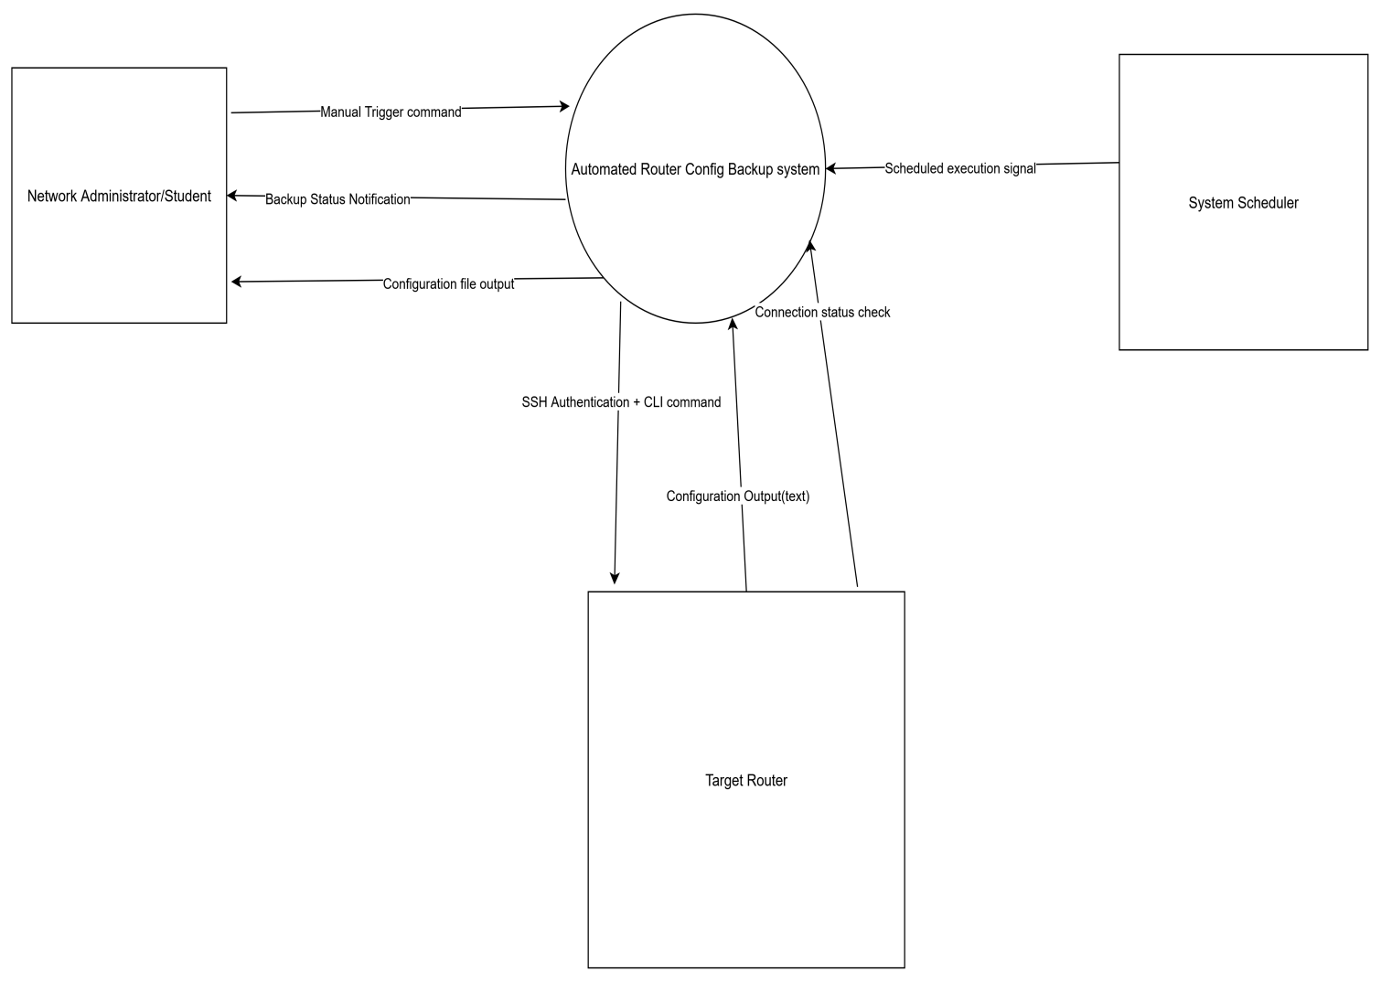

Data flows.
FROM | TO | DATA FLOW DESCRIPTION
Network Administrator | Automated Router Config Backup System | Manual Trigger Command – e.g., running the script from terminal
Automated Router Config Backup System | Network Administrator | Backup Status Notification – success/failure message or log summary
System Scheduler | Automated Router Config Backup System | Scheduled Execution Signal – daily trigger at set time (e.g., 2:00 AM)
Automated Router Config Backup System | Target Router | SSH Authentication + CLI Command – login attempt and show running-config
Target Router | Automated Router Config Backup System | Configuration Output (Text) – raw config returned via CLI
Automated Router Config Backup System | Target Router | Connection Status Check – optional ping or keep-alive check before backup

DATAFLOW DIAGRAM

The Level 1 Data Flow Diagram (DFD) presents a structured decomposition of the Automated Router Config Backup System into its core functional components, illustrating how data moves through the system in a secure, traceable, and automated manner. Each process is designed to perform a specific task within the configuration management life-cycle, ensuring modularity, maintainability, and clarity in system behavior.
The diagram begins with a scheduled trigger from the operating system’s task scheduler, which initiates the backup sequence without manual intervention, a critical feature for real-world ISP environments where continuous uptime and operational consistency are paramount. From there, the system retrieves device credentials from a centralized configuration store, establishes a secure SSH connection, executes the show running-config command, captures the output, saves it in an organized directory structure, and logs the operation status for auditing purposes. This end-to-end flow not only demonstrates automation but also incorporates error handling pathways that ensure failure, such as authentication errors or unreachable device, are properly recorded and reported.
By adhering to standard Gane & Sarson notation, the DFD maintains academic rigor while remaining accessible to technical reviewers. Its design reflects industry-standard patterns used in network automation tools like Ansible and RANCID, positioning this project not merely as a scripting exercise, but as a foundational model for scalable, auditable configuration management systems.
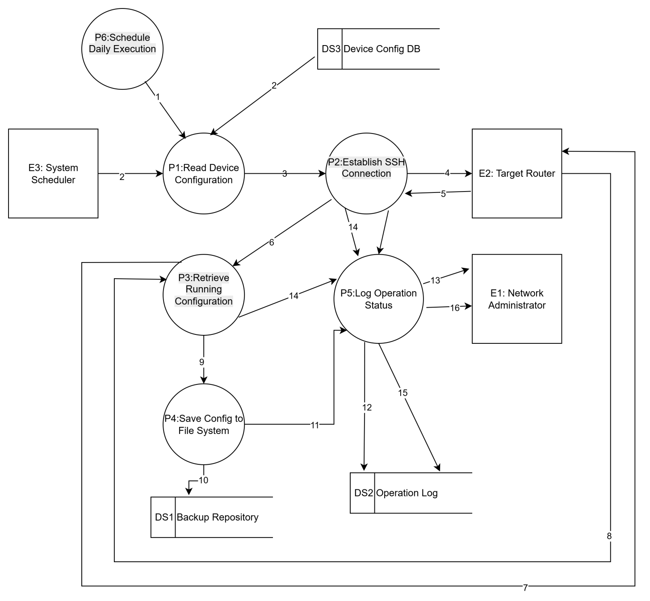
Data flows

NO. | FROM | TO | DATA FLOW
2 | E3 | P1 | Trigger daily execution
1 | P6 | P1 | Trigger automated execution(Daily signal starts the cycle)
2 | DS3 | P1 | Returns list of devices with IP, username, device_type (Input for automation)
3 | P1 | P2 | Device credentials (IP, user, pass, type)
4 | P2 | E2 | SSH login + authentication
5 | E2 | P2 | Authentication accepted
6 | P2 | P3 | Connection established
7 | P3 | E2 | Send command: show running-config
8 | E2 | P3 | Return config output (text)
9 | P3 | P4 | Raw config text + timestamp
10 | P4 | DS1 | Save config file: filename_path.txt
11 | P4 | P5 | Operation result: success
12 | P5 | DS2 | Write log entry: [SUCCESS]...
13 | P5 | E1 | Notify admin: Backup complete
14 | P2/P3 | P5 | Error detected: Timeout/Auth Failed
15 | P5 | DS2 | Write log entry: [ERROR]...
16 | P5 | E1 | Alert: Backup failed for 192.168.1.1

ENTITY-RELATIONSHIP DIAGRAM
The Entity-Relationship Diagram (ERD) defines the logical data model underpinning the Automated Router Config Backup System, emphasizing data integrity, traceability, and extensibility. It formalizes the relationships between key entities: Device, Backup Record, and System Log, using well-defined attributes and relational constraints that support both operational functionality and compliance requirements.
The Device entity serves as the source of truth for all managed routers, storing essential identification and access parameters such as IP address, hostname, and device type, while abstracting sensitive information like passwords through secure external storage mechanisms. Each time a configuration is retrieved, a new instance of the BackupRecord entity is created, capturing metadata including timestamp, file path, execution status, and failure reason if applicable. This enables historical tracking and rollback capability, an essential component of network governance frameworks such as NIST SP 800-53. Furthermore, the SystemLog entity provides granular visibility into system operations, allowing administrators to audit actions, diagnose issues, and verify successful executions. The use of primary and foreign keys ensures referential integrity across the dataset, preventing orphaned records and maintaining consistency even as the number of backups grows over time.

While the current implementation may utilize lightweight storage formats such as JSON files or flat logs, the ERD is designed with scalability in mind, allowing seamless migration to relational databases like SQLite or PostgreSQL as the system evolves. This forward-looking approach underscores the project’s balance between educational simplicity and professional-grade architecture.
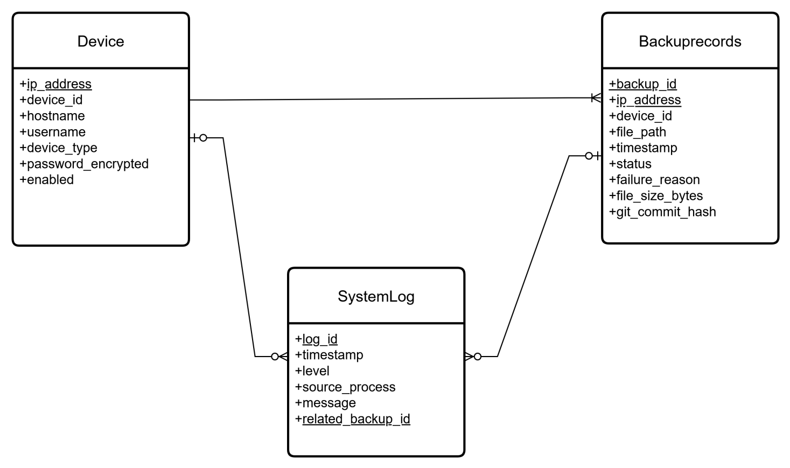

RELATIONSHIP | CARDINALITY | DESCRIPTION
Device → BackupRecord | One-to-Many | A single device can have many backup records over time
BackupRecord → SystemLog | Optional One-to-One | Each failed backup may generate one detailed log entry
Device → SystemLog | Optional One-to-Many | General logs (e.g., connection retries) linked to device

REFERENCES
- Broadband Forum TR-069. (2004). CPE WAN Management Protocol.
- Ubiquiti Networks. (2020). UniFi Controller Documentation.
- MikroTik. (2021). The Dude Network Monitoring System.
- Cisco Meraki. (2022). Cloud-Managed Networking Overview.
- Stallings, W. (2017). Foundations of Modern Networking: SDN, NFV, QoE, IoT, and Cloud

